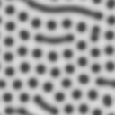

Convolution_GrayScale_0.03_0.061_1_0.5_128_3997_4000



Convolution_GrayScale_0.026_0.057_1_0.5_128_4000_4000

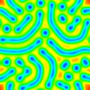

Convolution_LongRainbow_0.028_0.059_1_0.5_128_4000_4000

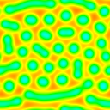

Delta_ShortRainbow_0.03_0.061_1_0.5_128_4000_4000

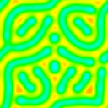

Delta_ShortRainbow_0.026_0.057_1_0.5_128_4000_4000

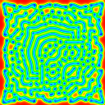

Perpendicular_LongRainbow_0.026_0.057_2E-05_1E-05_128_4000_4000

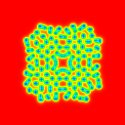

Perpendicular_LongRainbow_0.031_0.062_2E-05_1E-05_128_4000_4000



Perpendicular_YellowToRed_0.026_0.061_2E-05_1E-05_128_4000_4000

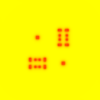

Perpendicular_YellowToRed_0.027_0.062_2E-05_1E-05_128_4000_4000



Delta_GrayScale_0.026_0.063_1_0.5_128_4000_4000